# From Pisa to Rome (and a ruptured appendix)

Wow, the places we've been and the things we've seen over the past week with our friends . . . we have sure sampled a wide variety of beauty and history all over Italy!

Before I launch into all the details of our travels and fun, I need to clarify WHO had the ruptured appendix . . .

It was my DAD!!

I don't have all the details, but I think he started having some significant pain and discomfort last Monday. It got steadily worse throughout the week, and then on Thursday he ended up in the ER. He had a large mass in his abdomen and a CT scan was ordered. Diagnosis: ruptured appendix, plus a major infection spreading around . . . He went into surgery shortly thereafter and they took care of the mass and the mess of the infection. They are leaving the surgical site "open" until Monday so that they can be sure the infection is all cleared up. Then he will go back into surgery again to close everything up. He will be in the hospital for several days they told him, and it will take 4-5 weeks for him to fully recover as well. Poor guy! He was in more pain than he could ever remember, and is still trying to find a good solution for pain management at this point. The morphine drip is no longer an option, and he didn't really like the oxycontin. So hopefully another option has been given recently so he doesn't have to continue to suffer. He is in my thoughts and prayers for sure!!

**Tuesday Update: They closed him up while I was sleeping during the night, and all is well. They are just waiting for his digestive system to kick into gear and then they will discharge him to go home and continue with his recovery. He is doing better now with the pain as well. Yay!!

Below: Scott and me in Vernazza, a village that's part of the Cinque Terre (where the Disney movie Luca was based). Cinque Terre is pronounced: chink-wah terr-ah.

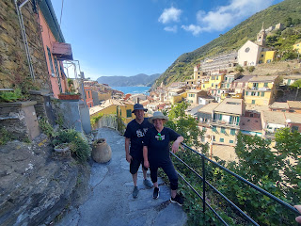

Last Sunday:

We took Rich and Andrea to visit the Romeo and Juliet Castles where Scott and I went earlier this spring. The castles are always very scenic and charming, with fantastic views of the valleys around, and the best part is that they are only about 25 minutes from our house! They are located in Montecchio Maggiore.

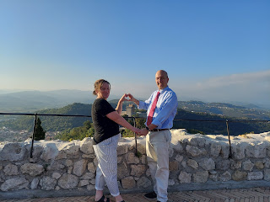

This Romeo of mine is so handsome!!

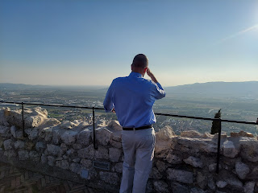

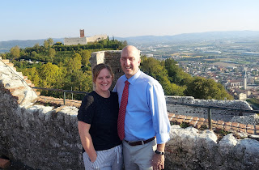

Rich and Andrea Garner

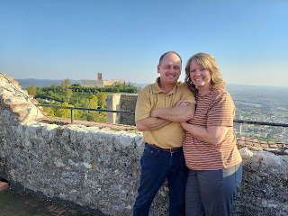

Rich and Andrea at the entrance of the Romeo Castle

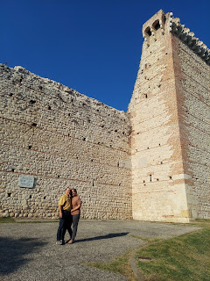

We had the families of the Horners and the Parkers over for desserts in the afternoon, since they serve in the bishopric with Scott. It was fun to hang out and visit for a couple of hours, while their kids hung out on the rooftop terrace and played all the board games that I have on hand. (Guess Who - Italian style, Candyland, Skipbo, etc.)

I didn't get a photo . . . whoops.

That evening we listened to another session of General Conference from 6:00-8:00 p.m. because of the time difference from Utah. I especially loved hearing from our prophet, President Russell M. Nelson, who is an amazingly energetic 98 year old. His message of love and encouragement was so perfect and meaningful to me. Not that I am having a hard time, but it was just so comforting and motivating that I couldn't help but feel moved by his words no matter what my circumstances are. He is truly an inspired leader and I am so grateful that we have a prophet on the earth today, just as in days of old.

I was also able to call and visit with my mom right after the conference session ended, since it was her birthday! We chatted for a while as I organized and packed for our upcoming 4 day road trip with the Garners. Happy Birthday, Mom!! She shared that she has plans to begin horseback riding lessons at a ranch out in Potter Valley (a few minutes north of Ukiah). She will first learn how to groom and saddle the horse, and then eventually get up and learn some basic riding skills. She and I both share a great love of horses and I'm so happy for her to have this wonderful opportunity!

Monday:

Leaving our house by 7:30 a.m., we drove over to La Spezia (along the upper west coast of Italy) where we parked the car near the train station for the day. We rode on the regional train over to the Cinque Terre, containing 5 small villages along the coastline.

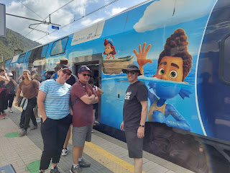

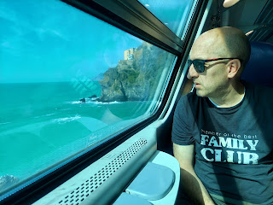

We chose to go to Monterosso first (the furthest of the 5 villages) to try to find some lunch, and then work our way back to the first village. Monterosso has the biggest beach of all the 5 towns, and is very expensive . . . most people want to hang out here because of the beach access, so you will definitely pay more for food here. We found a cheap joint on the beach and ordered burgers and a drink to give us enough energy for the afternoon.

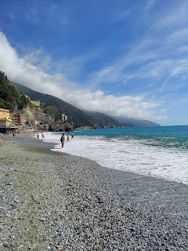

We hiked out on these huge slabs of granite that border the main beach.

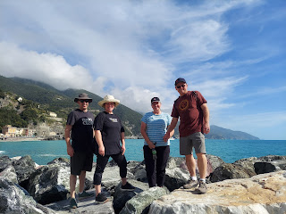

The granite goes on and on for days . . . and makes for a nice surface to explore on top of.

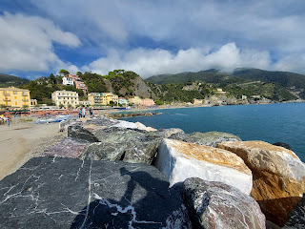

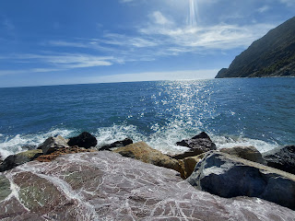

I even climbed down next to the water with bare feet so I could feel the water on my toes as it splashed onto the rocks around me. The tide was pretty high when we were there.

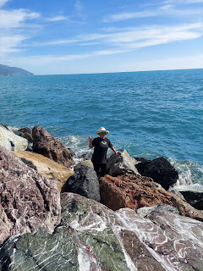

This huge Neptune-like statue was at the far end of the Monterosso Beach.

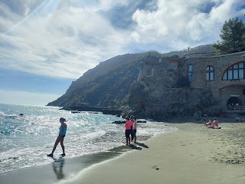

Next, we hopped on the train to go to Vernazza, the 4th town in the Cinque Terre. The train ride only takes about 3-4 minutes before you arrive at the next station. And with a Cinque Terre Pass, you can hop on and off the trains for the entire day, all for the price of just 18 euros. This also includes being able to hike on any of the trails, too.

Below: The "main street" of Vernazza. I hiked from Corniglia to Vernazza last October when I came over to Europe by myself. It was extremely strenuous and exhausting and very warm outside in the sunshine. This time it was nice to just get off the train and leisurely stroll into town without being all sweaty and tired . . .

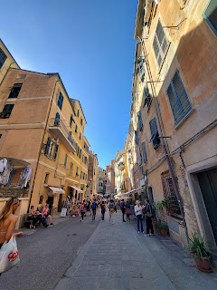

I took Scott, Rich and Andrea up to the top of the steps of Vernazza, right where I had come into town last year. The view is just stunning. Just going up those first several steps to get up to this spot, Rich and Andrea were marveling that I did that

whole section

of trail from Corniglia to here. We were huffing and puffing just to get to this first good vantage point, ha ha.

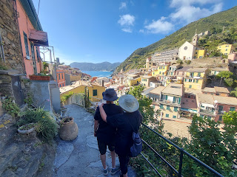

The walkways are very narrow but you get to walk where the locals actually LIVE. :)

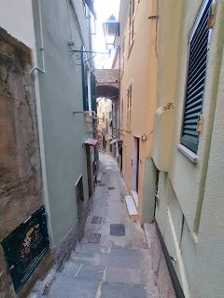

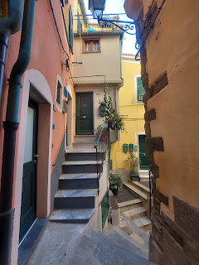

Vernazza also has a beautiful harbor at the end of the "main street".

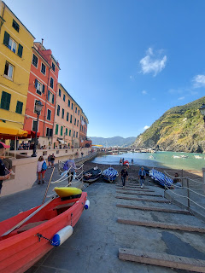

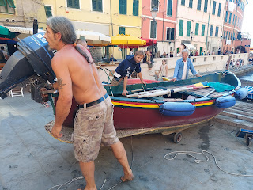

We watched a group of strong Italian men move boat after boat after boat down to the water together.

Video of their efforts: (9 seconds)

https://photos.app.goo.gl/sVWiuuSftkXi3Kha7

Another video of the men moving a boat: (23 seconds)

https://photos.app.goo.gl/WoZpthD8G8kbgyfJ8

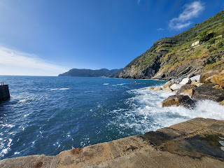

We enjoyed hanging out down at the harbor for a little while, and then we hopped on the train again. We tried Corniglia briefly, the 3rd of the 5 villages, but it's a bit less accessible and was too hot outside to try very hard. You get off the train, hike up a couple flights of stairs to the road, and then the line was ridiculously long to wait for a shuttle van to take you into town. Corniglia is the highest above the sea in the Cinque Terre, and it takes more effort to get into town from the train station. After we waited in line for over 15 minutes, with about 75 people in front of us, the shuttle van finally returned to pick up the next load of passengers. We counted how many they let in - only 15 - and decided to abort our efforts in Corniglia. It would be a very long time of standing in the sun to get our turn in the shuttle van. The only other option was to walk into town. Blech. It's a very steep walk uphill, and a lady coming back on foot told me it took them about 20 minutes to get there. No thanks. So we hopped back on the train and went to the next town.

Manarola is the 2nd village in the Cinque Terre. It is charming as well and has a very nice harbor.

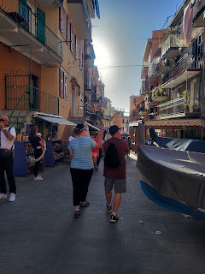

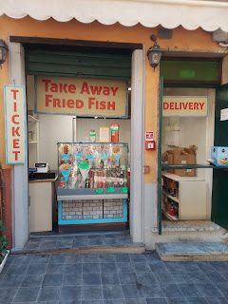

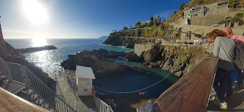

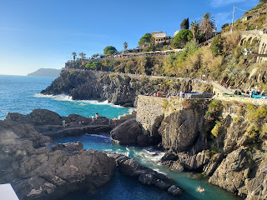

We skipped going to the 1st town of Riomaggiore because we were running out of time in the day. Sadly, it will have to wait for another visit . . .

We took the train back to La Spezia (about 15 minutes) and found our car once again. All was well. As we drove through La Spezia to head south to Pisa, we saw this ginormous cruise ship in the harbor of La Spezia. It must be a happening place because it's so close to the Cinque Terre!

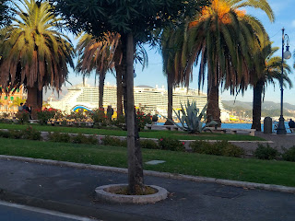

It was very complicated and frustrating trying to check into our AirBnB in Pisa, due to the VERY specific instructions, along with all the dark and narrow streets that were within the walls of ancient Pisa. Eventually we got in and settled for the night.

Here are Rich and Scott relaxing on the bed together . . . lol

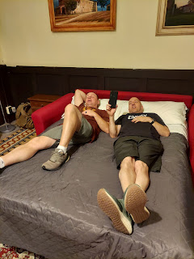

We walked over to see the Tower of Pisa at night (about 8 minutes from our AirBnB), something I would have never thought of doing before. It was so cool! I tried several times to get a photo that showed how much the tower was leaning, but it always looked pretty normal in each one . . .

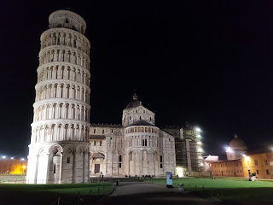

Finally I got this one . . . Andrea, Rich and Scott are standing there talking about all the engineering issues and their verticalness helped to show the leaning contrast of the tower.

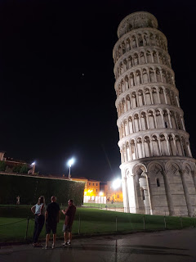

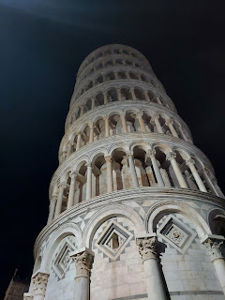

We found some kebab "take-away" on our walk back to the AirBnB. Old Town Pisa is pretty cool within the ancient (and huge) walls. This statue and fountain was situated in a huge piazza as we took our food home to eat before bed.

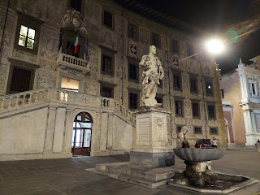

Tuesday:

The following morning we got up and walked back over to the Tower, bought our tickets, and went up inside.

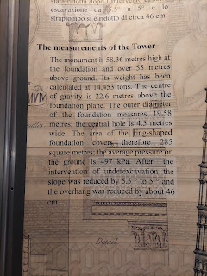

Andrea has a fear of falling, which is slightly different than a fear of heights. But the spiral staircase that went on and on, and leaned significantly on one side, made for some severe nausea and dizziness by the time she made it up to the top.

Once we got up to the top, we stayed up there for quite a while. It was relaxing and beautiful at 9:00 a.m.

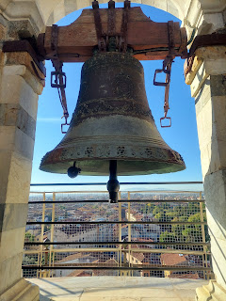

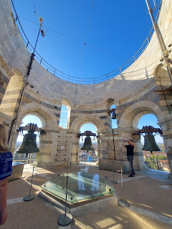

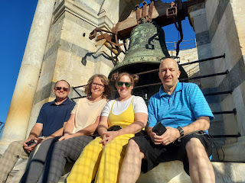

Scott said, "What if we kiss on top of the tower?" So we did. :)

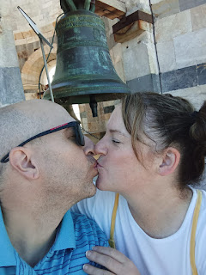

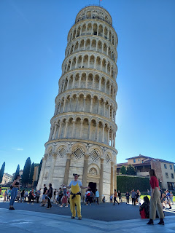

After taking a few more photos, we went next door to see the giant Cathedral that I didn't get a chance to see last year. It was very impressive!

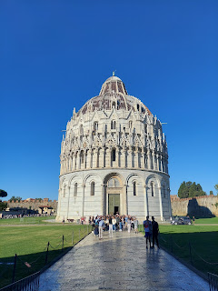

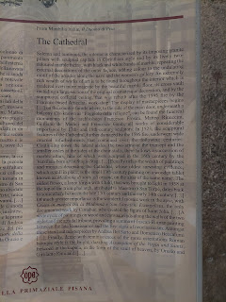

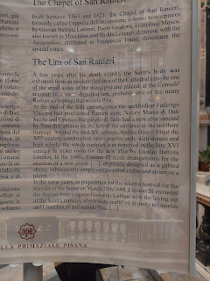

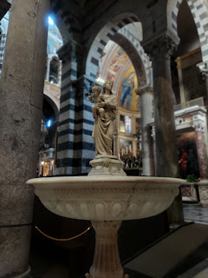

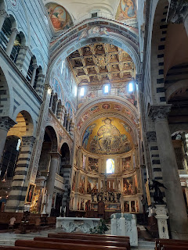

Below: This was by far the oldest thing in the Cathedral . . . the "Virgin and Child", from the year 1226.

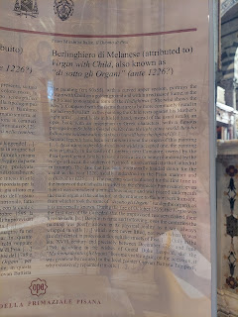

The painting, infused with gold, can be seen in this next photo.

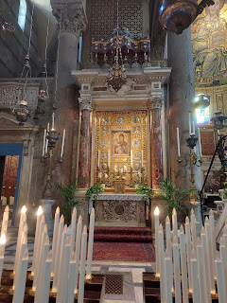

Never forget to

look up

inside any cathedral.

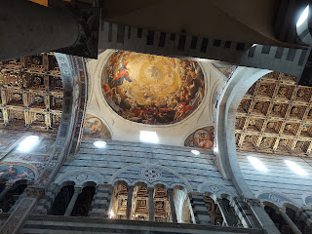

After we finished wandering around the Cathedral, we headed south for a long drive down to Rome (about 3.5 hours).

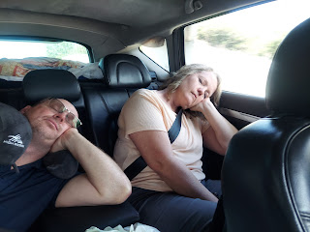

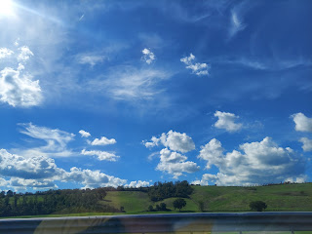

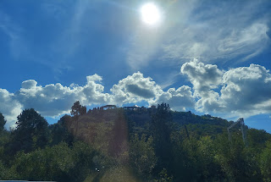

We went directly to the Rome Temple, since it's located on the north side of the city. We enjoyed the temple visitor center before going inside the temple to perform some sealing ordinances for a few deceased family members.

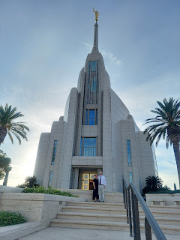

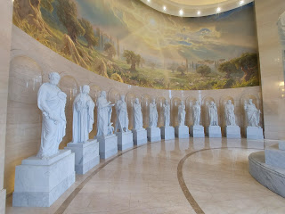

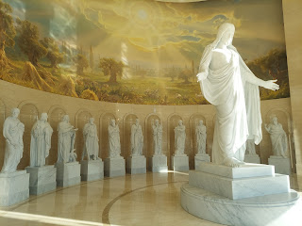

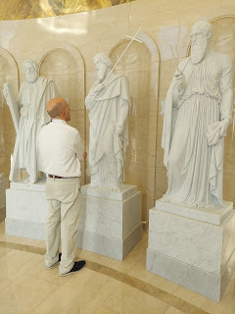

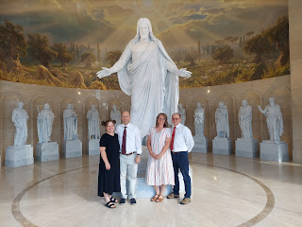

Temple sealings are very sacred. They are an eternal marriage between a man and a woman, valid for time and all eternity (as long as you are doing your best to keep God's commandments). When a loved one has passed away and did not get the chance to have this sacred sealing performed while living upon the earth, we can perform the sealing in their behalf in the temple, the House of the Lord. Once the sealing has been performed by proxy (in their behalf), it is still up to them to choose to accept it or reject the ordinance where they are in heaven. There is always the freedom to choose for one's self, even beyond the grave.

I felt the spirit really strong when we sealed Thurza Jane Rawles, my 2nd great grand-aunt, to her spouse, George Burger. Thurza was born in 1834 and was the older sister to my 2nd great grandfather, Thomas Edward Rawles. Thurza, who went by her middle name of Jane, and George were married for over 50 years before George passed away first in 1901. They married in Glenwood, Iowa in 1854 and crossed the plains to CA by ox team together. What a life! "Jane" lived until 1918 and was 84 years old at her passing. When I was at the altar in the sealing room, I felt the joy of Jane and George filling the room and it made my eyes fill with tears. I'm sure they have many stories of the adventures they had together, and I'd love to hear them someday.

When we got out of the temple, Andrea Garner and I both had the same instinct to call our children and grandchildren on WhatsApp to share the beauty of the temple grounds with them before leaving. I only caught Jacob briefly as they were in the grocery store, but I got to connect with Amber, Abby and Gwen for a bit longer.

The girls were on fall break from school this past week, so they were all hanging out together at home. In the photo below, Abby is showing me all the tiny silver star stickers she put on her face as "makeup". :)

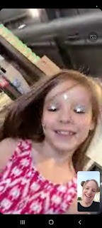

We successfully made it to our next AirBnB in the heart of Rome, with nary a problem. Parking was nonexistent, but Rich noticed someone about to pull out of a spot so we backed up and were able to snag the spot right away. It was only one block away from our lodging, which was very helpful. Later that evening, we found a spot even closer and we were able to park the car there for the remainder of our time in Rome.

We found some delicious Venezuelan food about 5 minutes' walk from our apartment. I ordered the shredded chicken "sandwich", which is held together with fried plantain patties in place of a bun. It was AMAZING.

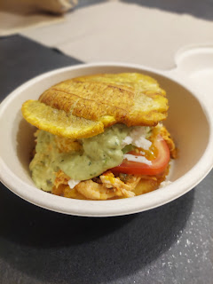

Wednesday:

We got up bright and early again to do our pre-paid tour of the Colosseum, Roman Forum, and Palatine Hill. Rich had done most of the research for this area, so I knew little or nothing before going. The Colosseum is HUGE and only a shell of the original structure. But there is still plenty to see and absorb with what remains.

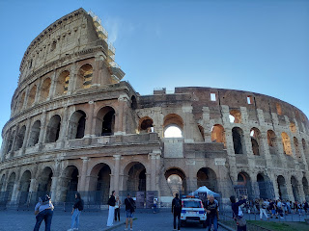

Scott and me in the foreground . . .

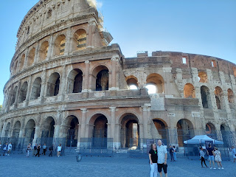

Entering the Arena Floor . . .

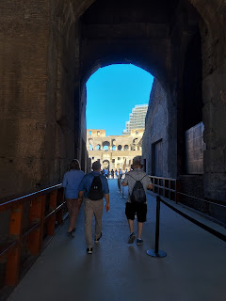

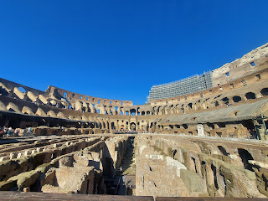

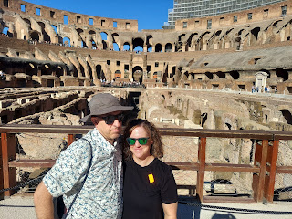

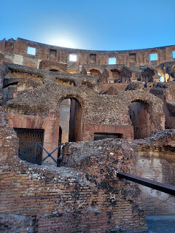

Video of when we entered the Arena floor for the first time: (33 seconds)

https://photos.app.goo.gl/UDvccYi9pxhgZTYp7

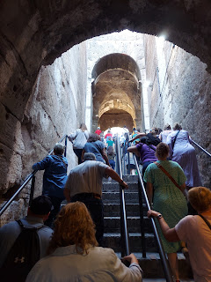

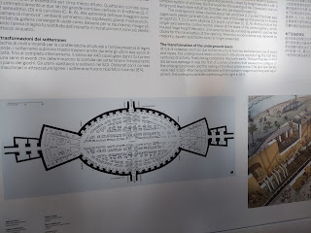

There were TONS of people everywhere inside. For it being the "off-season", it was still pretty packed.

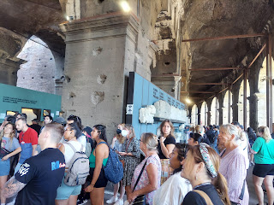

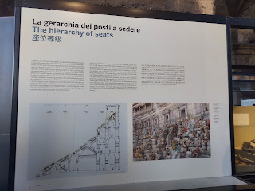

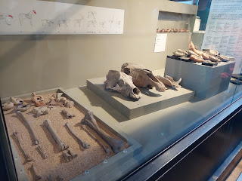

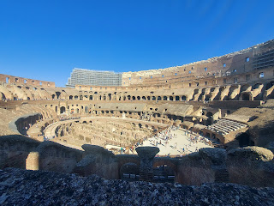

The Arch of Constantine is still standing next to the Colosseum. It was built in 315 AD in honor of when Constantine gained a victory in the Battle of Milvian Bridge (312 AD).

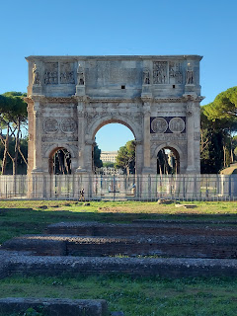

Passing the Arch of Constantine, we walked "next door" to the Roman Forum, what used to be the central hub for the Romans for centuries - even back to the 800-700 BC time frame. It was like an ancient Main Street, linking commerce, government buildings, public celebrations, and even gladiator marches.

The view looking down from Palatine Hill toward the Roman Forum.

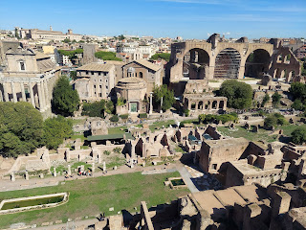

Video of the massive span: (18 seconds)

https://photos.app.goo.gl/xGny7Vc1GHubWHbz8

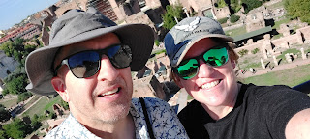

The Arch of Titus

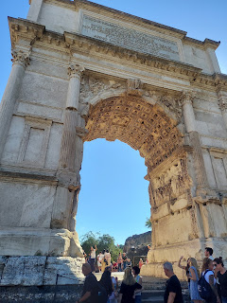

Description of the Arch of Titus:

(in photo below) The inscription records the dedication of this arch by the Senate and the people of Rome to the emperor after his victory over Judea (AD 70). Scenes from the conquest are sculpted on the inside: one panel shows the procession with the booty taken from Jerusalem, including the seven-branched candlestick; on the other is Titus on his chariot, followed by Victory and personifications of the people and the Senate; on the outside is the procession of the defeated Jews.

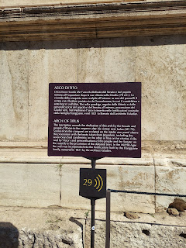

A Roman cat on the prowl . . .

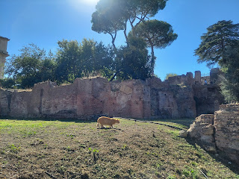

I didn't realize how much the Romans influenced the production of olive oil until I read this:

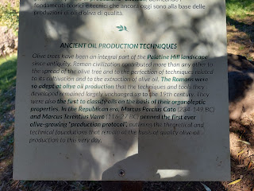

A beautiful (and old) olive tree . . .

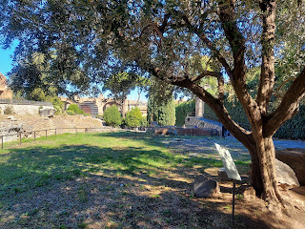

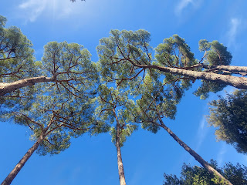

Oh, you know . . . just me walking among some ancient Roman ruins . . . no big deal . . .

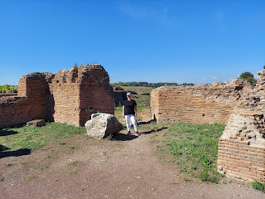

So many fountains around Rome, all of which were lovely.

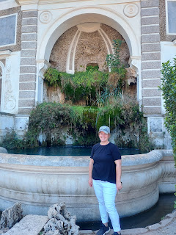

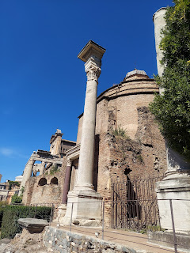

Below: This is called the Temple of Romulus, built by the emperor Maxentius in AD 307. The bronze doors are original and the lock still works!! He built it in honor of his son, who died in childhood.

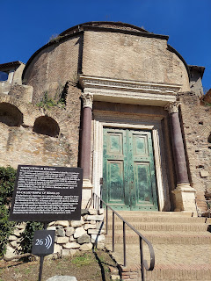

Ancient Burial Grounds - dating back to 900-700 BC. It was discovered during excavations in 1902.

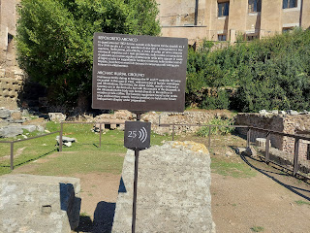

A thoughtful (and restful) moment.

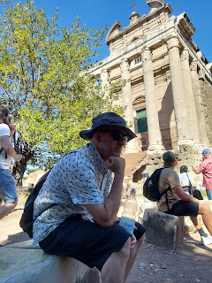

So many columns . . .

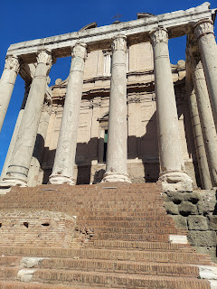

And then we found the column graveyard . . .

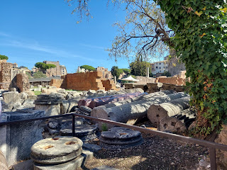

Statue of Julius Caesar - he lived from 100 BC to 44 BC when he was assassinated. According to the internet, he transformed Rome from a republic into an empire during his reign.

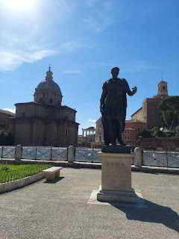

As we left the Roman Forum and Palatine Hill and walked toward the Altar of the Fatherland, the streets were wide and full of interesting things to see.

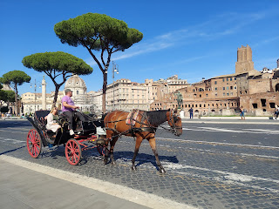

Video of a guy playing his sweet guitar, and Scott loving it so much he walked over to give him some money: (27 seconds)

https://photos.app.goo.gl/SBuMmQfc1EPHtANm6

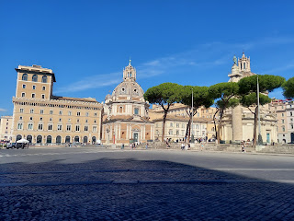

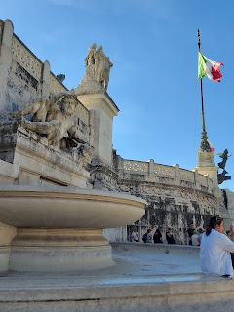

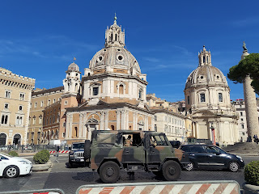

Altar of the Fatherland (below): a large national monument built between 1885 to 1935 to honor Victor Emmanuel II, the first king of a unified Italy. I just learned that Italy, as we know it today, was not the actual country of Italy until 1861!! At that point, it became known as the Kingdom of Italy. Here is the website I found that explains it all very nicely.

https://www.carpediemrome.com/blog/altar-of-the-fatherland/

How interesting to learn that Italy is younger than the United States of America!!

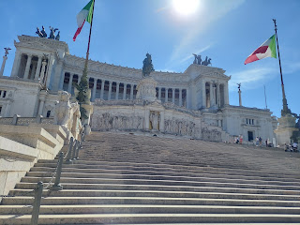

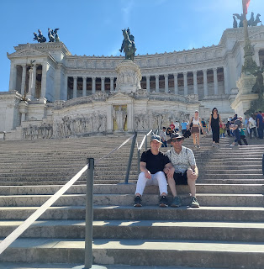

Below: The Tomb of the Unknown Soldier (Italian style). These cauldrons are kept constantly lit, and the area is guarded by the Italian Armed Forces. It is meant to honor those who fell during WWI.

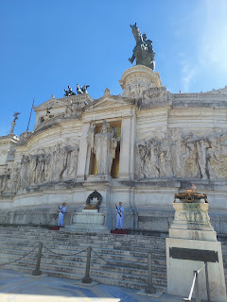

This massive statue is depicting Victor Emmanuel II atop his victorious horse . . .

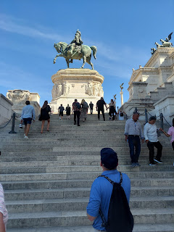

Views from the top of the Altar of the Fatherland . . .

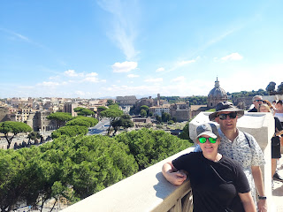

Next stop: the Trevi Fountain, found in Trevi Square.

It was pretty crowded there, more so than in many of the other places we had been. Everyone was trying to squeeze into a spot to toss the obligatory coin over your shoulder and get a picture.

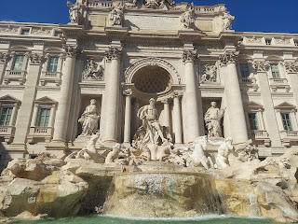

I had a hard time thinking of a good wish to make with so many people crowded around me, but I finally settled on one.

Video of the coin toss: (8 seconds)

https://photos.app.goo.gl/ZXhNTFTrHcvGYLjg8

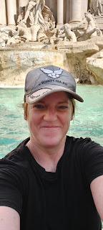

Video of the swarms around me: (26 seconds)

https://photos.app.goo.gl/TH4G3fcCSDHLwt9v8

A short distance away from the Trevi Fountain is the Pantheon. What a cool building! Out in front I noticed two sister missionaries from the Church of Jesus Christ of Latter-day Saints, so I went over to talk to them. They were having their P-Day (preparation day = a day to do laundry, run errands, or go sight-seeing). One was from Illinois and the other was from Utah. We enjoyed visiting with them for a bit before we got in line for the Pantheon. :)

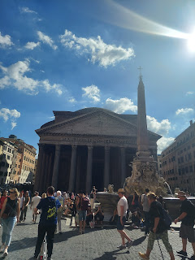

In the Greek language, "pan" means everything and "theon" means divine. It is close to 2,000 years old!! What made this Roman Temple so special is that it was built to be used by the common people for the very first time. Typically, Roman Temples were only to be accessed by priests or those with special privileges. Anyone else who entered could be punished by death! But now it was a place where everyone could have access and worship and commune.

The mathematical dimensions alone were enough to pique Scott's and Rich's interest. Everything was built in perfect symmetry - both in height and in breadth. On an Italian website (link below), it states the following: "The space is a perfect sphere symbolizing the vault of heaven; the height of the dome is the same as its diameter, creating perfect balance and unique harmony." The site also says, "On entering the door, the effect you feel is meant to be overwhelming. You suddenly find yourself in this huge empty space which causes vertigo and makes you feel tiny. This is how you were supposed to feel in front of the Gods."

Italian website:

https://www.italyguides.it/en/lazio/rome/ancient-rome/pantheon

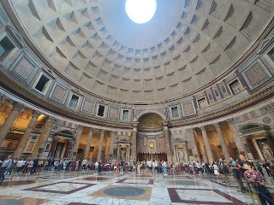

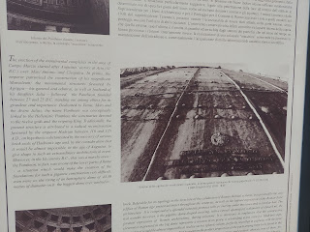

A beautiful statue of Mary and Baby Jesus

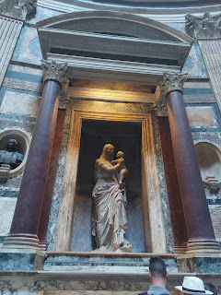

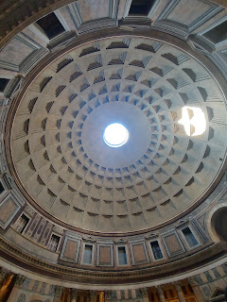

Rich saw online that there was a church nearby that was only open briefly each day and that houses a statue made by Michaelangelo. It was about a 4 minute walk from the Pantheon, so off we went.

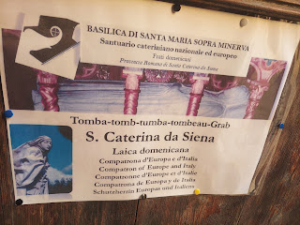

The altar area in front . . .

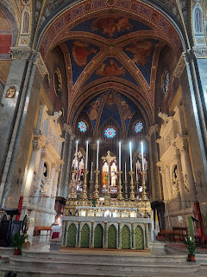

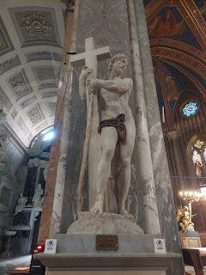

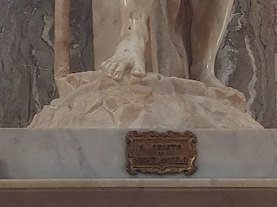

Michaelangelo started the first marble statue in 1514 but had to abandon it partway into the project because a black streak appeared on the white marble near the face of Christ. He started over again in 1519 and finished it in 1520. In one article online, it said that Michaelangelo was reluctant to do this project. No one knows why the Roman patrician, Metello Vari, asked Michaelangelo to create Jesus Christ naked after the Resurrection. There was some discussion that it was intended to show His strength through the contours of his muscles. The bronze loincloth was added later on and nobody is quite content with that either.

Matello Vari also requested that there be a crucifix added to the statue to represent Jesus' conquest over death, but art enthusiasts didn't like that so much either. They said the size of the cross was incongruent with the size of the actual accomplishment of the Crucifixion of Christ. Basically, Michaelangelo just did what he was asked to do, but some feel that it was a list of odd requests made of him.

Michaelangelo was quickly made famous for his perfect representation of body parts (muscles, sinews, proportions) in his sculptures and how accurate and lifelike the poses were. One quote said, "Christ's knees (in this particular statue) were worth more than all of Rome put together."

I was just in awe of standing in front of yet another work of art by the famous Michaelangelo. Just happy to be there . . .

We moved along in the direction of our AirBnB once again. If we saw something interesting on the way, we'd pause briefly to take it in before moving on.

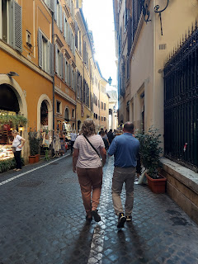

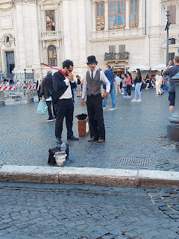

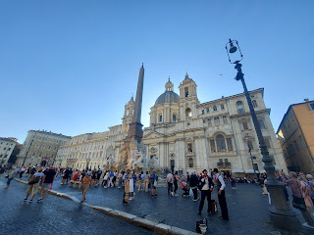

Rich especially loved this fountain but I don't know the name of it.

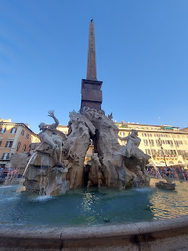

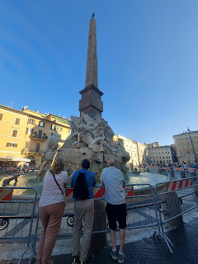

I got a call from Charmaine from the other side of the world as we started walking again. It was so great to hear from her! As we passed the Castle of Sant' Angelo, since I was otherwise preoccupied on my phone, I asked Scott to grab a photo for me.

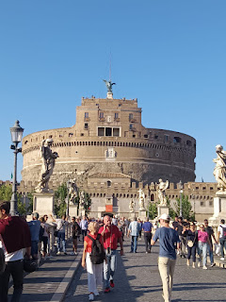

It was built between AD 134 and AD 139, originally commissioned to be a mausoleum for the Roman Emperor Hadrian and his family. It is now a museum.

For dinner, we ate at a nearby restaurant called "Slurp". The full name is Paninoteca Slurp, ha ha. They have paninis, salads, seafood, pasta, etc. I ordered a smoked salmon salad and it was delicious.

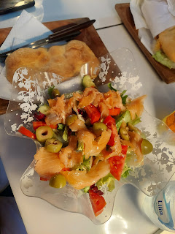

When you're sitting outside to dine, you are basically a form of live advertisement for the restaurant. As people walk by and see someone eating there, then they are more likely to be curious and interested to eat there as well. The owner was super friendly and spoke very good English. At one point he brought out a huge bowl of fresh mussels for us to eat - as a gift! I think he was just happy that we were there dining as a group of four. We chose this place because it was rated 4.8 out of 5. When you pair good food with additional free (and good) food it's no wonder why the ratings are so high . . . :)

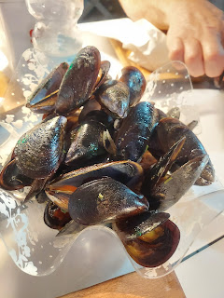

Thursday:

Another early morning for all of us . . . this was our day to tour Vatican City, about a 6 minute walk from our AirBnB. Our tickets for the Vatican Museum Tour and Sistine Chapel was set for 8:30 a.m. so we left before 8:00 to walk over and get in line.

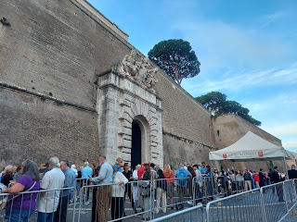

Part of a large inner courtyard at the Vatican.

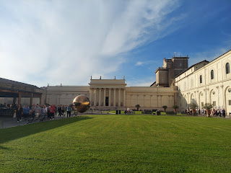

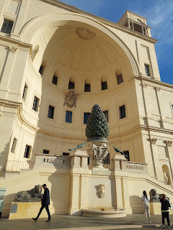

"A Sphere Within a Sphere", created in 1990.

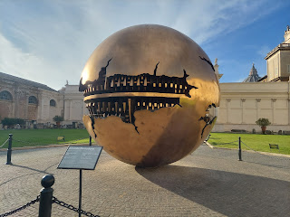

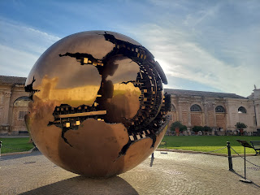

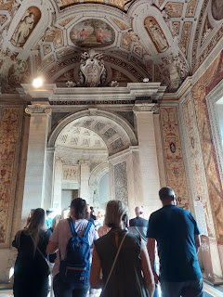

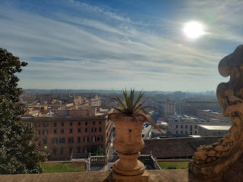

Random bust of some guy with a flower pot on his head . . . LOL

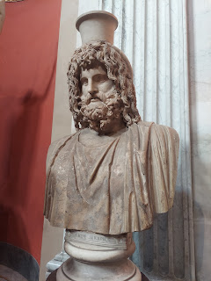

The amount of detail in these floor to ceiling tapestries was just unbelievable!! I have no idea how anyone could make something so artistic and precise using thread and a weaving loom . . .

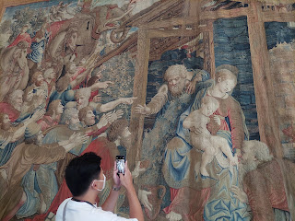

I really liked the loooong hallway of maps  . . .

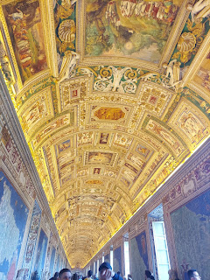

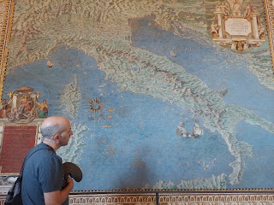

For all the photos from the day, you can click here: (trust me, there are some beautiful pieces of art!!)

https://photos.app.goo.gl/pQbDCjFhCQn6VJKb6

Our guide, Nicoletta, really knew her stuff! I think she has a great love of art because that was the main focus of her presentation to us. I especially loved the story of this painting in the Vatican Museum. It's called, "The School of Athens," created by the artist Raphael, a young up-and-comer and supposed rival of Michaelangelo. He painted it between 1509-1511.

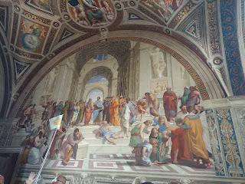

Nicoletta pointed out to us how Raphael painted himself (over on the right, black hat) looking directly at the audience . . .

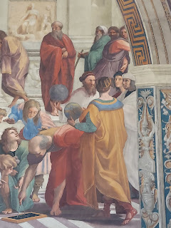

And then he painted Michaelangelo looking down at the ground, seemingly despondent or moody to some extent . . .

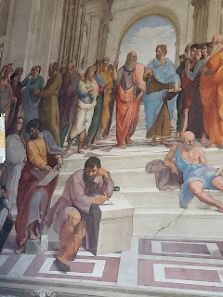

Supposedly this was Raphael's way of saying that HE was looking toward the people and the future, whereas Michaelangelo was looking downward and toward the past. A little poke at his "rival" . . .

Nicoletta also showed us where several of the giants of that era (scientists, philosophers, etc) were incorporated into the painting: DaVinci, Galileo, Plato, Aristotle, Socrates, etc.

This website is very helpful to explain what we see in the painting and all the symbolism within:

https://artincontext.org/the-school-of-athens-raphael/

There are even some YouTube video links on the web page above that discuss this particular painting if you don't want to

read

the article . . .

After a morning of shuffling along in a tour and seeing a great deal of art, we took a break and went back to collect our things from the AirBnB and tuck them in the car. Then we went to a nearby McDonald's for lunch. Technically, we had a better idea of where to get lunch, but it didn't open for another 45 minutes and we didn't want to sit around and wait. There are McDonald's located every few blocks in Rome, so we decided to just go for it. It was certainly more classy inside the restaurant here than any McDonald's I've ever been to in the U.S. And the food was more elevated in presentation and flavor as well. Good job McDonald's in Europe! Too bad it isn't that great in America . . .

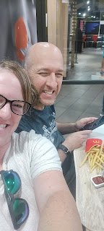

After lunch, we walked back over to the Vatican City area so that we could see one more historic site: St. Peter's Basilica.

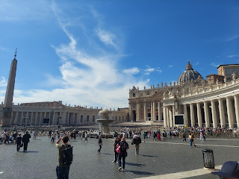

Below: This is where the Pope gives his weekly address (if he's in the country - - which, by the way, Vatican City is the smallest country in the world!!). Every Wednesday morning, if he's home, he will give a public address. You can get tickets to sit in the seats outside and hear him in person. Pretty cool!

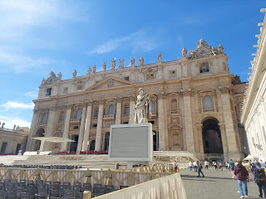

The Basilica is HUGE. But then, have we seen anything yet in Rome that isn't huge??

Take note of these statues on top of the Basilica because they will provide some context for what we did next . . .

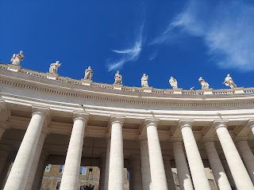

We let Rich and Andrea take the lead on what to see and do in Rome, but one thing that I really wanted to do was to go up inside the Dome of the Basilica and see all of Rome from up top. Andrea was brave enough to come with me and I was grateful for her company. The line was long and time-consuming just to get to the ticket booth. It took us about an hour just to get our tickets and begin our ascent.

You could pay 10 euros and take an elevator 2/3 of the way up and walk the other 1/3 of the stairs . . . OR you could just go on foot the entire way and pay a whopping 2 euros LESS, ha ha. We chose the 8 euros opportunity and went on foot. It's a total of 551 steps up and then 551 steps back down. That would make 1102 steps in all - if you're counting . . .

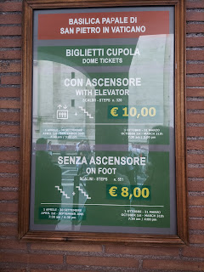

As we made our way thorugh the long line to the ticket booth, at least there was some beautiful art to enjoy while we waited. These were made out of tiny little mosaic tiles.

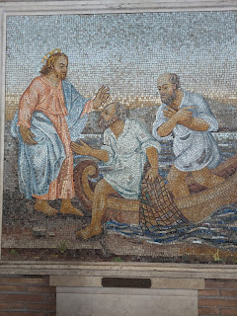

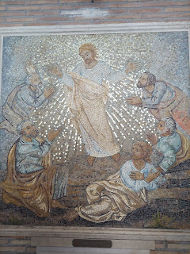

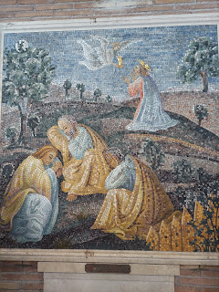

Finally we got our tickets and started up. This is the first main landing area and the little chimney building seen below has some significance. This is where smoke is sent out as a signal whenever a new Pope has been chosen, letting everyone know that the decision has been made.

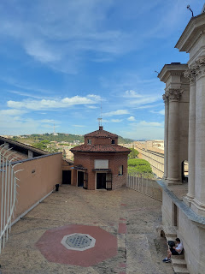

Inside the Dome, there is a catwalk of sorts where we could walk around half of the circumference. There are tall gates or fencing the entire way, which sort of interferes with photo opportunities. But the dome above was mostly visible.

Note the center of the Dome. There is a tiny cupola at the top there - a tiny dome within a dome. We found another set of stairs - almost on accident - and were able to go up inside that thing!!

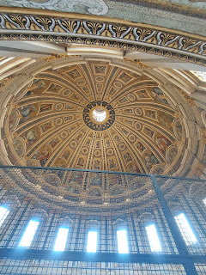

Video inside the large Dome area: (29 seconds)

https://photos.app.goo.gl/W8veXFA7dnJAU2sZA

We messaged Rich and Scott from the Dome, and Rich was the first to find the spot we invited them to go so that we could see them and they could see us. Can you see the large black circle on the floor down below?

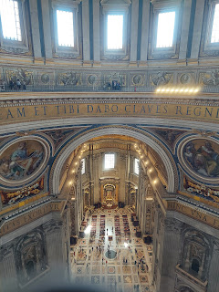

We directed them to that black circle and then told them to look up where we were waving at them from above. It was fun to connect from that dizzying height!

As we left the Dome, I just happened to spot this sign, indicating another segment of stairs to go up even higher.

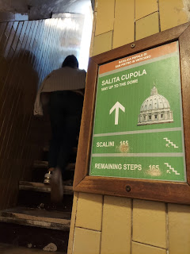

We huffed and puffed up the narrow stairwells, which also included some sections of tiny spiral steps. We had to take some breaks, and we desperately wished that we had brought our water bottles with us . . .

Notice the leaning walls of the cupola - - and yet the walkway itself was flat in this section.

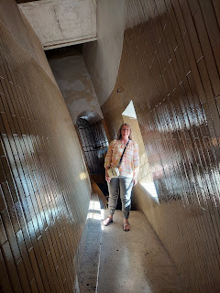

Finally, here was our reward . . .

Do you see the statues on the building roofline below? Those are the same statues I mentioned earlier. But this time, we are high above them all.

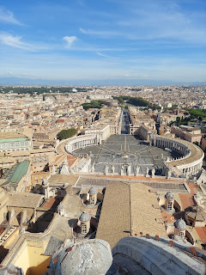

Andrea and I were pretty red-faced and sweaty (and dehydrated) at the top, but we were glad we made it because the view was so amazing. :)

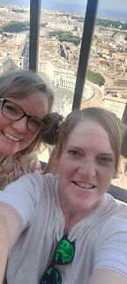

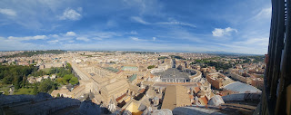

Once we reunited with the menfolk far below, we guzzled our water and rested for several minutes before wrapping up our self-guided tour of the Basilica.

We found the famous work of Michaelangelo, "The Pieta", enclosed behind bullet-proof glass.

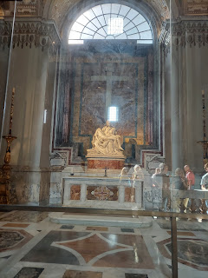

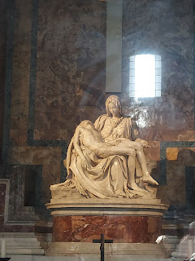

When we researched why it was behind the glass, we learned that several years ago a crazed man came in and started attacking the statue of Mary holding the deceased Son of God on her lap - with an AXE!! Thankfully, guards were able to grab him before he thoroughly destroyed this cherished work, and now it is kept safe behind the glass. We can only come as close as a gated-off point now. Yikes!

Here is my bestie. In St. Peter's Basilica. In Vatican City. In Italy. Who-dathunk??

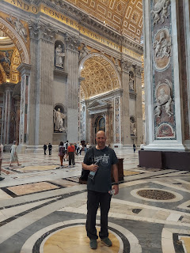

Below: Me, with the large bronze altar work of Bernini behind me. It is called, "St. Peter's Baldachin" and marks the location of where Peter, the original apostle of Jesus Christ in New Testament times, is buried down in the necropolis below the Basilica. Next time I come here, I really want to go down underneath and see the places where so many famous people are buried, including Peter the Apostle.

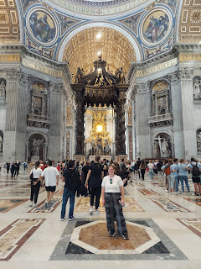

Rich and Andrea - this shot gives a little bit of perspective on the vastness of the Basilica. There are 4 distinctive wings that extend out from the center, this being just one of them.

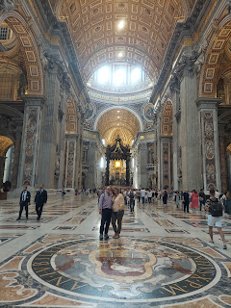

As we exited, I saw a Catholic priest coming through this gated arch on the side of the Basilica.

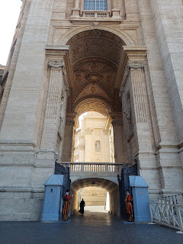

It felt so dramatic and somehow triumphal, with the grand but simple entrance that he made. This photo (below) would make a great movie poster . . .

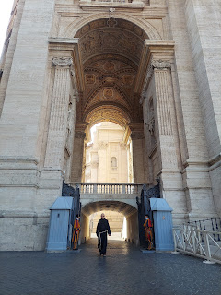

Swiss Guards have been guarding the Pope here since 1506. They are single men, between the ages of 19-30. They also have to be Catholic. Go figure . . .

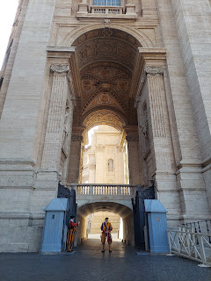

Here is another view of the front of the Basilica where you can see the statues along the roofline again.

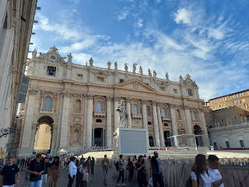

All done. What a whirlwind in Rome! We came, we saw, and we conquered.

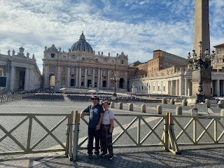

Below: One of many places to fill up your water bottle throughout the city or Rome. The water is cold and fresh.

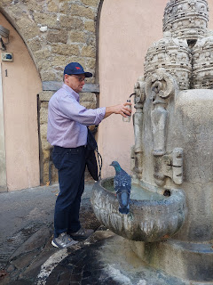

Time to get in the car and head north back up to Vicenza.

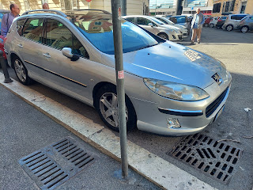

We were so lucky to get this spot so close to our AirBnB. Rich found it the night that we arrived in Rome. While the men went to retrieve the car from the other spot a block away, Andrea and I stood in the new spot to hold it until they arrived. We had to turn someone away during the one minute we held our ground. As soon as a spot opens up, it's usually filled in about 15 seconds . . .

It took quite a bit of finessing to fit our longer car in such a small spot, but Rich was a pro as he helped Scott get it parked successfully. Scott was also smart to check on it multiple times a day, and whenever possible, he'd back it up a few more inches so that he could eventually pull out a little easier when it was time to leave.

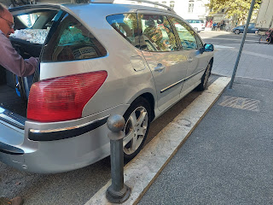

Video of Scott pulling out on Thursday with more confidence than the 81-point turn he had to make on that first night to squeeze it in: (17 seconds)

https://photos.app.goo.gl/QFDYbFDkeirFU9Xh6

The 5 hour drive home was uneventful, with one exception.

Around the half-way point, we were discussing pulling over soon at one of the many rest stops next to the highway that offer a restaurant and gas station. All of a sudden, our car went psycho on us!! It lurched and started revving super high, like it was in 1st gear going 80 mph. Scott tried shifting into neutral a couple times, and then back into drive. He was having to apply the brakes at the same time that the car was acting like it wanted to win the Daytona 500 . . . lucky for us, a rest stop was less than 2000 meters away and we could pull off the highway.

As we pulled in to park, Scott was using all his might to brake and steer the car as it was still chomping at the bit. We could smell the brakes burning at this point, too. He pulled into a parking spot, a little wonkily, and then promptly shut off the engine. A small amount of smoke was also coming out from under the hood. We came in with a bang and several people were staring at us, like ARE YOU OKAY???

Immediately, an Italian long-haul truck driver came running over to take a look. He hopped into the driver's seat and turned on the car, drove it a few feet, and gave us a thumbs up. He didn't speak any English, but he knew about cars. Scott said that as soon as he was able to shut off the engine, it's like the computer was able to do a "re-set" and turn off the crazy psycho switch that somehow took over. So it was driveable again, but we let it rest for several minutes before we drove off. We also said a prayer that A) we could feel confident in our decision to drive, and B) that we could get home safely.

Thankfully, we did make it home safely a couple hours later. We want to get it checked soon and possibly even just sell the car and get another one. That was unnerving, to say the least.

Friday:

After a fairly decent night of sleep, Avery arrived Friday morning for us to watch her over the weekend. Kylie wanted to go to Sardinia with some friends to celebrate her birthday, and Benson had to work all weekend.

We borrowed a highchair from a friend in our ward here, and it turned out to be a lifesaver!!

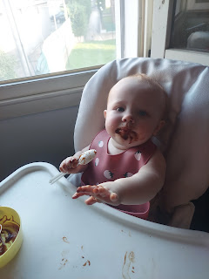

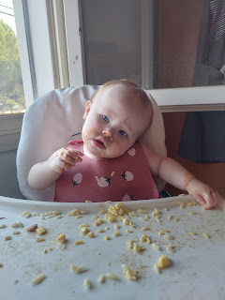

We parked her next to the kitchen window where she could watch all the happenings outside, especially all the cars driving around the roundabout next to the gas station. Several times a day, I would just stand at the window with her and she would be in a trance watching all the cars, motorcycles, and buses going around the circle. We would stand there watching for at least 20 minutes each time . . .

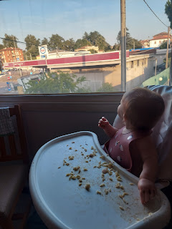

Her other happy place was hanging out in bed with us. She loved the comfy pillows, blankets, and being flanked by us on either side.

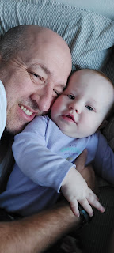

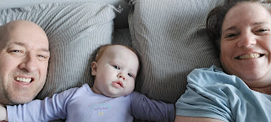

I bought her some cute new clothes at Kiabi, my favorite Italian store. She is growing so fast and needed some 12 month clothes. I think she could even fit in some 18 month clothes at this point . . .

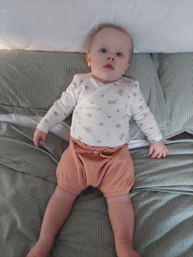

She is super snuggly and very chill most of the time. Once in a while she'll get a sudden burst of energy and she'll do a jerk and clench her fists in excitement, like she's about to burst! ha ha ha

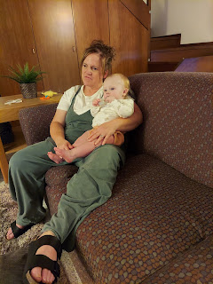

She does a stink-bug crawl everywhere which is so stinkin' cute.

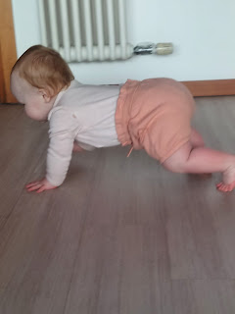

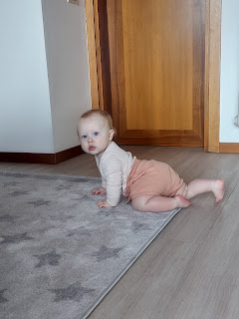

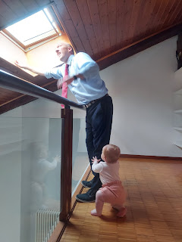

I love all the funny expressions Scott and Avery had up on the roof where it was so bright . . .

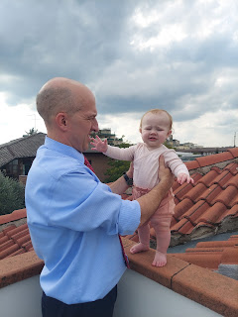

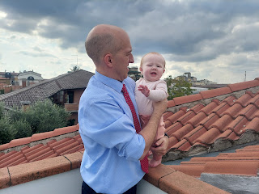

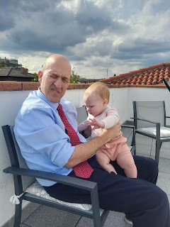

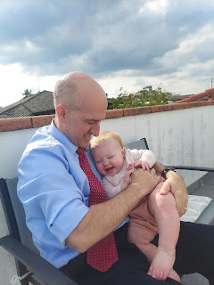

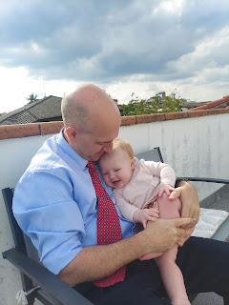

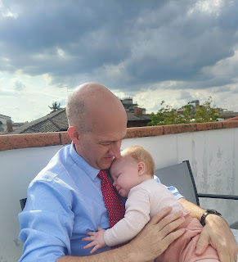

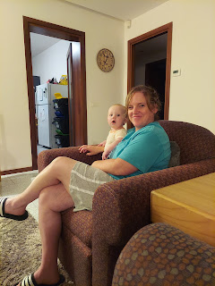

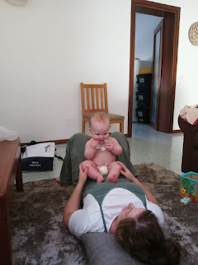

Video #1:

Avery trying a carrot for the first time. Rich and Andrea used to give their little ones a giant carrot to gnaw on during teething issues. (16 seconds) Avery really liked it!

https://photos.app.goo.gl/QpfbHxWSHby3iVvEA

Video #2:

Avery playing with an empty water bottle and Andrea is making silly faces at her. (You can see Andrea in the window reflection behind Avery) (25 seconds)

https://photos.app.goo.gl/6xsKPmqqMa5RZpCZ6

Video #3:

Avery crawling stink-bug style. Not sure what made her upset though . . . (5 seconds)

https://photos.app.goo.gl/yC4Z3kT37yDDGFAy5

Video #4:

Hanging out in our room on the bed, her happy place. (19 seconds)

https://photos.app.goo.gl/mtVBz4jw5QgE3GjH9

I took her to church with me Sunday morning. I tell you what, I don't know how these young mothers do it all . . . It's like I'm back to square one again and forgot how much it takes to get out the door by a scheduled time when you have a little one!! LOL

Somehow we made it though.

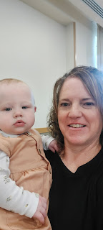

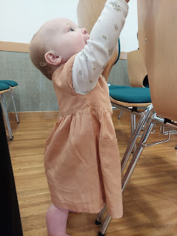

She did great up until the end of Sacrament meeting. That's when she didn't want anything that I had brought for her, ha ha. Didn't want my house keys, the apple slice, the baby cheese puffs, the carrot, her bottle, nothing. I stood in the back with her for the closing song and prayer and then we went home afterwards.

During the meeting, I handed her off to Scott at one point, since he was sitting up on the stand - so that I could bear my testimony. I shared my testimony of missionary work and of how much our Father in Heaven and His Son Jesus Christ love every person, no matter where they are in life or how close they are to the "path" leading to Heaven and happiness. It's important for us to give a lot of love to those who choose differently than we do, and to do it in the best possible way for them to receive that love. We have to meet people where they stand, to love them where they are, and to be a true friend. Jesus set the perfect example, and I am so grateful for Him in my own life. I am happier, more at peace, and unafraid of my own future because of Him.

Late Sunday night, we got to see Benson when he came to pick up Avery. It was so wonderful to see his face and hug him several times. He is having a hard time in life right now, since he and Kylie have decided to get a divorce. We are sad for them, but we give them our wholehearted support as they step into their future - apart.

Benson will be heading to South Korea in March or April for his next assignment. He told us that Korea wasn't even on his list of preferences! But somehow he is headed there anyway. He'll be there for 2 years. Meanwhile, as soon as Avery gets her passport, in the next month or so, Kylie and Avery will be moving back to Idaho Falls where her family also resides. Benson is sad that he will be so far from Avery, but is hoping to stay connected through modern technology when he can't come home for a visit.

We pray for them multiple times a day and hope they can navigate through everything with dignity and kindness toward each other.

Yesterday (Monday), was the first full day of relaxation that I've had in weeks!! I worked on this blog here and there, but mostly just relaxed. I didn't have to get up at a certain time, or hurry to do this or that, and it was WONDERFUL!! Scott had the day off from work, too, so we just hung out together. We went to the gym and worked out, laid around and watched The Voice, ate food, and vegged out. It was so perfect.

Today he is back to work. I'm finishing up this blog and doing laundry here at home. A perfect stay-at-home sort of day. :)   I love homebody days about as much as I love adventures out in this big beautiful world of ours.